CRICKET LIVE ANALYTICS DASHBOARD USING CRICBUZZ API
(Project Documentation)

1. Abstract
The Cricket Live Analytics Dashboard using Cricbuzz API is a real-time sports analytics application developed to provide live cricket insights through an interactive web dashboard. The application integrates the Cricbuzz RapidAPI with a PostgreSQL database to collect, store, and analyze live and upcoming cricket match information.
The system automates data collection using REST APIs, processes JSON responses, and stores structured match information in a relational database. The stored data is further analyzed using SQL queries to generate meaningful insights, including live match statistics, match status distribution, team performance, venue analysis, and historical match records.
The dashboard is developed using Streamlit and provides multiple modules such as Dashboard, Live Matches, Upcoming Matches, Match History, CRUD Operations, and Analytics. Interactive visualizations created using Plotly help users understand cricket statistics in an intuitive manner.
The project demonstrates the complete workflow of API Integration, Data Processing, Database Management, SQL Analytics, and Interactive Dashboard Development, making it a practical implementation of real-time data analytics using modern Python technologies.
Keywords: Python, Streamlit, PostgreSQL, SQL, REST API, Cricbuzz API, Data Analytics, Sports Analytics.
2. Introduction
Cricket is one of the most popular sports worldwide, generating a large amount of live data during every match. Players, analysts, broadcasters, fantasy sports platforms, and cricket enthusiasts rely on accurate and real-time information to monitor match progress and analyze team performance. Accessing this information efficiently requires a system capable of collecting, processing, storing, and visualizing continuously changing data.
The Cricket Live Analytics Dashboard using Cricbuzz API has been developed to address this requirement by integrating real-time cricket data with modern data analytics techniques. The application automatically retrieves live and upcoming match information from the Cricbuzz API, stores it in a PostgreSQL database, and presents meaningful insights through an interactive Streamlit dashboard.
The project combines REST API integration, SQL database management, data visualization, and web application development into a single platform. Multiple dashboard modules allow users to monitor live matches, explore upcoming fixtures, analyze historical records, perform SQL-based analytics, and search cricket data using various filters.
This project demonstrates practical implementation of data analytics concepts and provides hands-on experience with real-world API integration, relational databases, SQL querying, and dashboard development using Python.
3. Problem Statement
Cricket matches generate a large volume of real-time information, including live scores, match status, venue details, team performance, and upcoming fixtures. Although this information is available through various online platforms, it is often scattered across multiple sources and does not provide a centralized environment for data storage, SQL-based analysis, and interactive visualization.
The objective of this project is to develop a real-time cricket analytics platform that integrates live data from the Cricbuzz API with a PostgreSQL database. The application should automatically collect match information, organize it into a structured database, and provide meaningful insights through SQL queries and interactive dashboards.
The system should support real-time match monitoring, historical match tracking, data filtering, CRUD operations, and analytical visualizations to help users understand cricket statistics more effectively. The platform should also provide a simple and user-friendly interface for exploring cricket data without requiring direct interaction with the database.
4. Objectives
The primary objectives of the Cricket Live Analytics Dashboard are:
- Integrate real-time cricket data using the Cricbuzz RapidAPI.
- Store live and upcoming match information in a PostgreSQL database.
- Maintain historical match records using an automated scheduler.
- Develop an interactive dashboard using Streamlit.
- Perform SQL-based analytics to generate meaningful cricket insights.
- Provide CRUD operations for searching and filtering match records.
- Visualize cricket statistics using interactive charts and tables.
- Build a scalable and modular application following industry-standard development practices.

5. System Requirements
5.1 Functional Requirements
The Cricket Live Analytics Dashboard provides the following functional features:
- Fetch live cricket match data using the Cricbuzz RapidAPI.
- Retrieve upcoming match schedules.
- Store match information in a PostgreSQL database.
- Synchronize live and upcoming cricket data through a centralized dashboard sync mechanism.
- Update live match records and historical snapshots without duplicate entries.Maintain historical match snapshots.
- Display live scores and match details through the dashboard.
- Search match records by team name.
- Filter matches based on format, status, city, and venue.
- Generate SQL-based analytical reports.
- Export match history and match records in CSV format.
- Display interactive charts and statistical summaries.
5.2 Non-Functional Requirements
The system is designed to satisfy the following non-functional requirements:
- User-friendly and responsive interface.
- Fast data retrieval from the PostgreSQL database.
- Modular project architecture for easy maintenance.
- Scalable database design for handling additional match records.
- Secure API key management using environment variables.
- Reliable data storage and retrieval.
- Cross-platform compatibility.

6. Technology Stack
Technology | Purpose
Python | Backend development
Streamlit | Interactive web dashboard
PostgreSQL | Relational database
SQL | Data querying and analytics
Pandas | Data manipulation
Plotly Express | Interactive visualizations
Cricbuzz RapidAPI | Live and upcoming cricket data
Git & GitHub | Version control
Visual Studio Code | Development environment

7. System Architecture
The Cricket Live Analytics Dashboard follows a modular architecture where live cricket data is collected from the Cricbuzz API, processed, stored in a PostgreSQL database, analyzed using SQL queries, and finally displayed through an interactive Streamlit dashboard.
The architecture consists of the following major components:
- Cricbuzz RapidAPI – Provides live and upcoming cricket match data.
- API Integration Layer – Sends API requests and receives JSON responses.
- Data Parsing Module – Extracts required fields from the API response and converts them into a structured format.
- The Scheduler module - synchronizes live and upcoming cricket data, updates the database, and maintains historical match snapshots by avoiding duplicate records.
- PostgreSQL Database – Stores live matches and historical match records.
- SQL Analytics Layer – Executes analytical SQL queries for generating insights.
- Streamlit Dashboard – Displays dashboards, analytics, live scores, upcoming matches, and CRUD operations through a user-friendly interface.
System Architecture Diagram

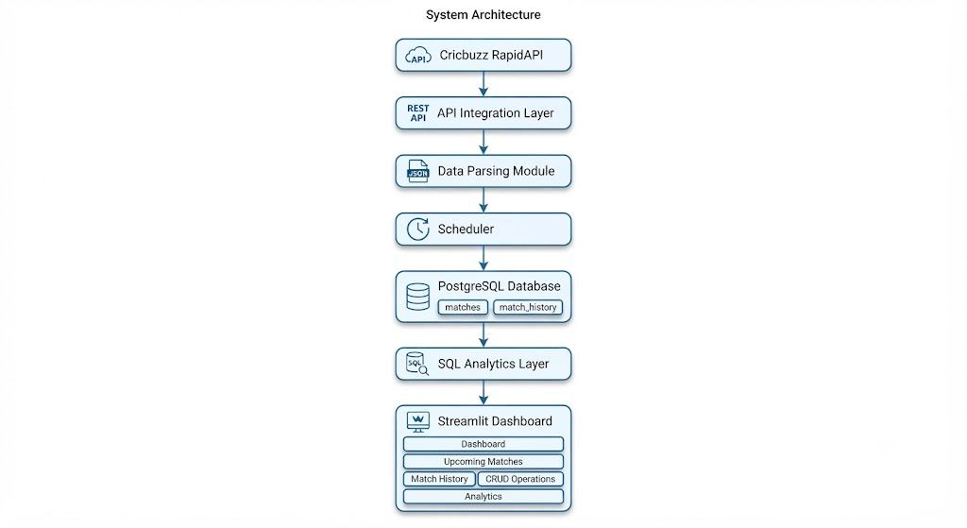
Figure 1: System Architecture of the Cricket Live Analytics Dashboard

8. Database Design
The application uses PostgreSQL as the primary relational database for storing cricket match information. The database is designed to maintain both the latest live match data and historical match records.
Database Tables
1. matches
This table stores the latest information for each cricket match fetched from the Cricbuzz API.
Important Fields:
- Match ID
- Series Name
- Match Format
- Match Status
- Team Names
- Team Scores
- Overs
- Venue
- City
- Start Time
- End Time
2. match_history
This table stores periodic snapshots of live match scores generated by the scheduler.
Important Fields:
- Fetch Time
- Match ID
- Team Names
- Team Scores
- Overs
- Match Status
This table helps maintain historical score progression for completed and ongoing matches.
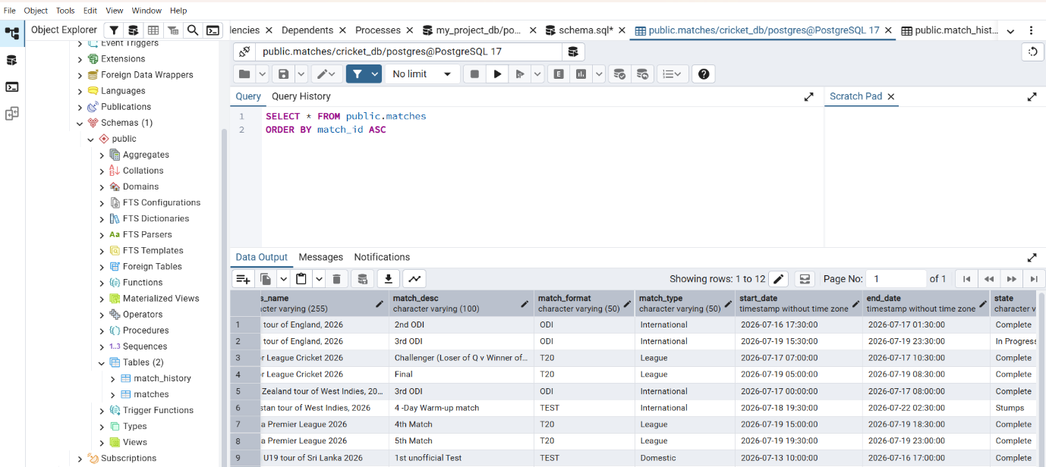
Historical records are inserted only when live match information changes, preventing duplicate snapshots.

Figure 2: PostgreSQL Database Schema (matches and match_history tables)
9. Project Modules
The Cricket Live Analytics Dashboard is divided into six independent modules. Each module performs a specific task such as displaying live match information, upcoming fixtures, historical records, SQL analytics, and database operations. This modular architecture improves maintainability, scalability, and user experience.
9.1 Dashboard Module
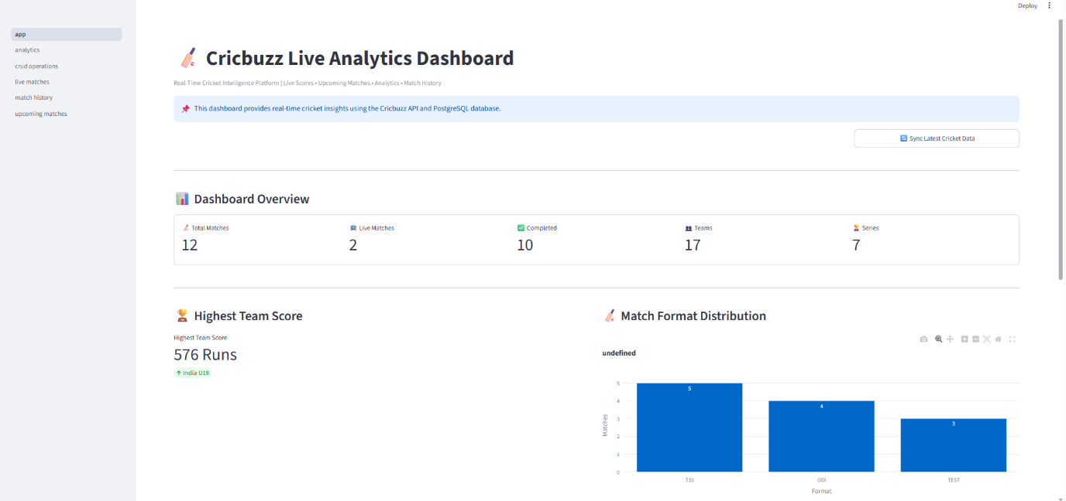
The Dashboard module provides an overview of the complete cricket analytics system. It displays important Key Performance Indicators (KPIs), including total matches, live matches, completed matches, total teams, and total series. It also presents interactive visualizations such as match format distribution, match status distribution, highest team score, and top venues, allowing users to quickly understand the overall cricket statistics. The Dashboard also serves as the central synchronization module of the application. A "Sync Latest Cricket Data" button allows users to update live matches, upcoming matches, and match history in a single operation before exploring other dashboard modules.

Figure 3: Dashboard Overview

9.2 Live Matches Module
The Live Matches module displays real-time cricket match information retrieved from the Cricbuzz API. It shows the names of participating teams, live scores, wickets, overs, current match status, and venue details. This module enables users to monitor ongoing cricket matches through a simple and interactive interface. The module reads the latest synchronized data directly from the PostgreSQL database instead of making API requests on every page visit. This approach improves application performance, reduces unnecessary API calls, and ensures consistent data across all dashboard modules.

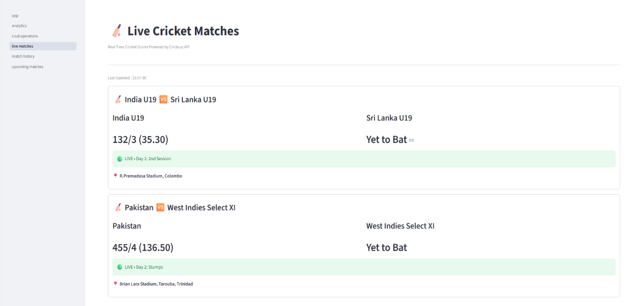
Figure 4: Live Matches Module

9.3 Upcoming Matches Module
The Upcoming Matches module provides information about scheduled cricket fixtures. It displays upcoming matches along with details such as series name, participating teams, match format, venue, city, and scheduled start time. This helps users stay informed about future cricket events.
Upcoming match information is displayed from the synchronized PostgreSQL database after dashboard synchronization. This approach minimizes unnecessary API requests, improves application performance, and ensures that users always view the latest available upcoming match data.
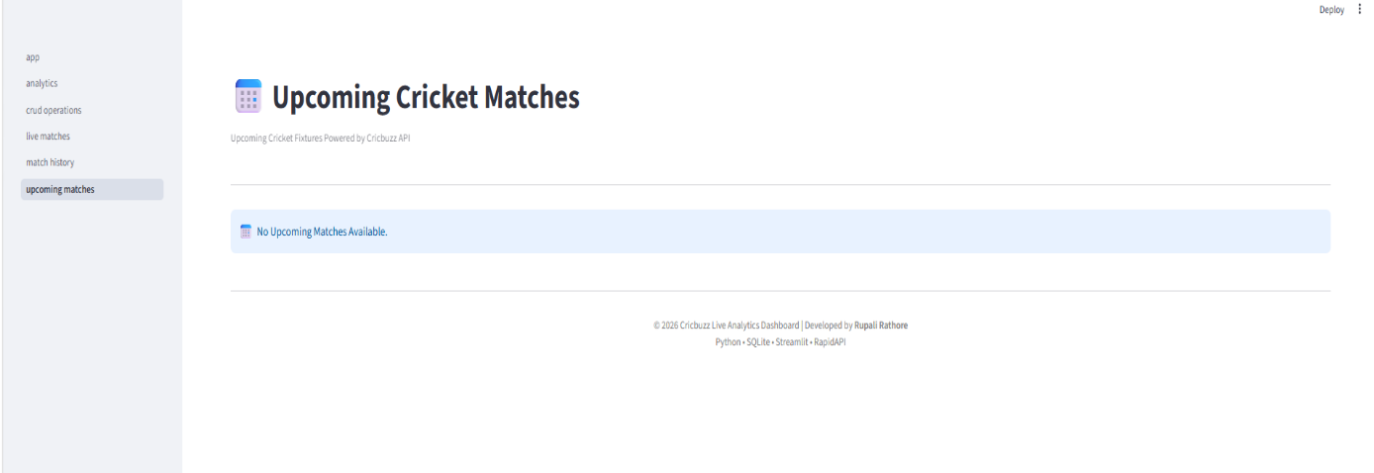

Figure 5: Upcoming Matches Module

9.4 Match History Module
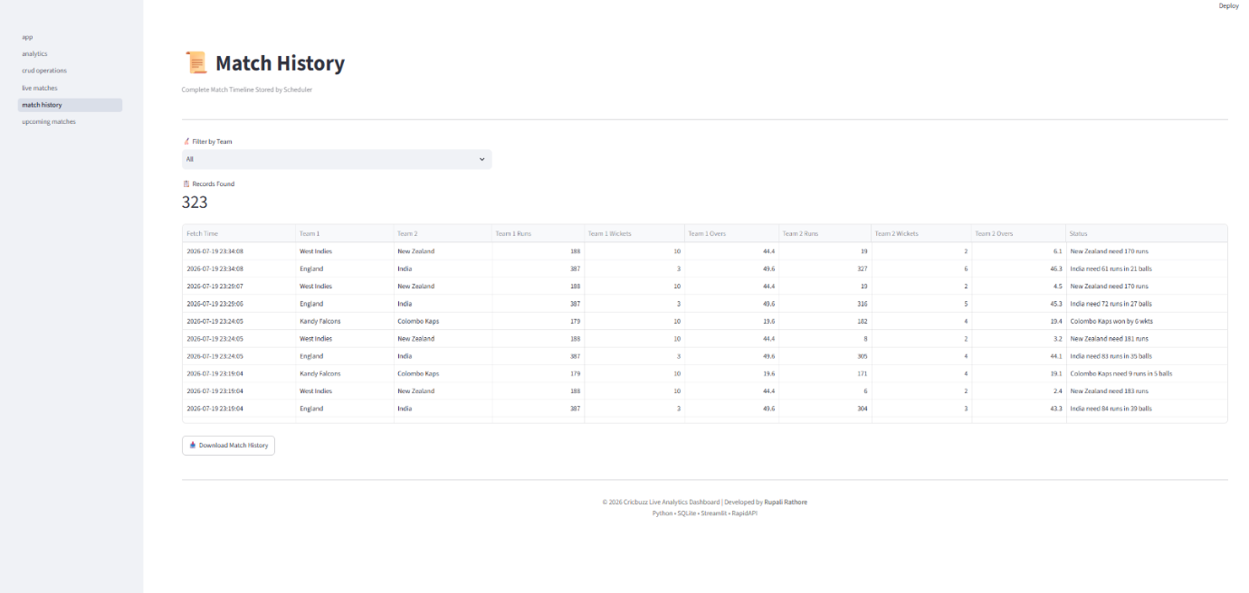
The Match History module maintains historical snapshots of live cricket matches collected by the scheduler. Users can filter records based on team names and download the match history as a CSV file. This module supports historical analysis of match progress and score updates.

Figure 6: Match History Module
9.5 CRUD Operations Module
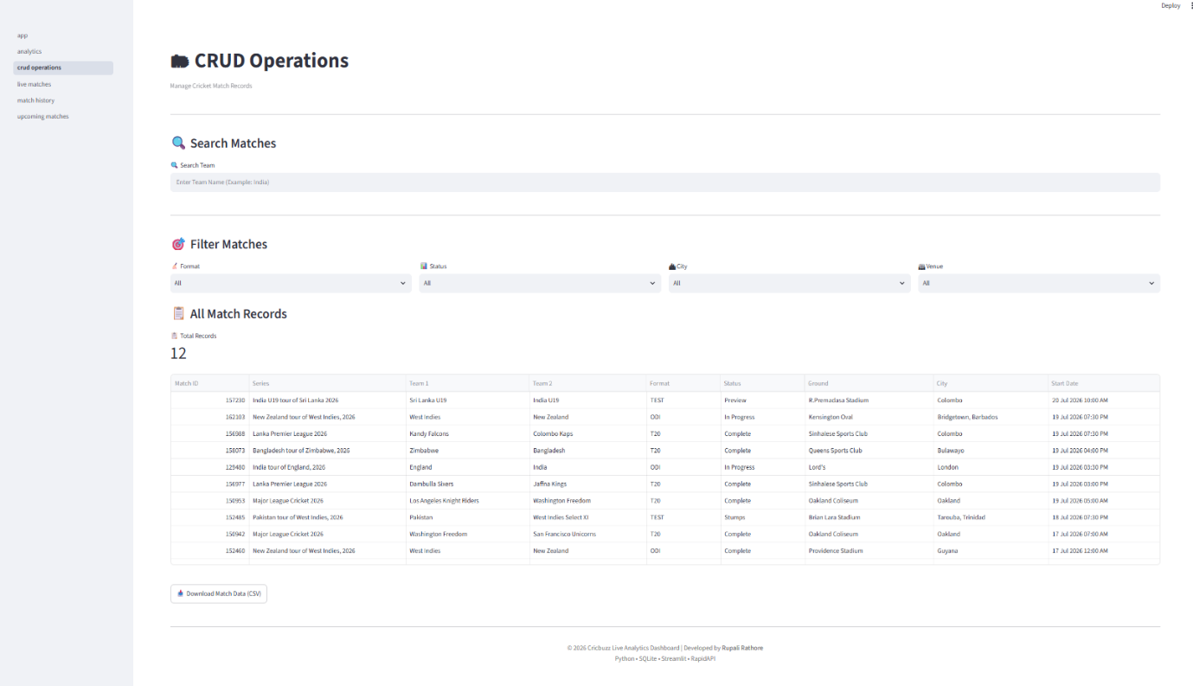
The CRUD Operations module allows users to search and filter cricket match records stored in the PostgreSQL database. Records can be filtered by team name, match format, match status, city, and venue. The filtered results can also be exported as CSV files for further analysis and reporting.
Figure 7: CRUD Operations Module
9.6 Analytics Module
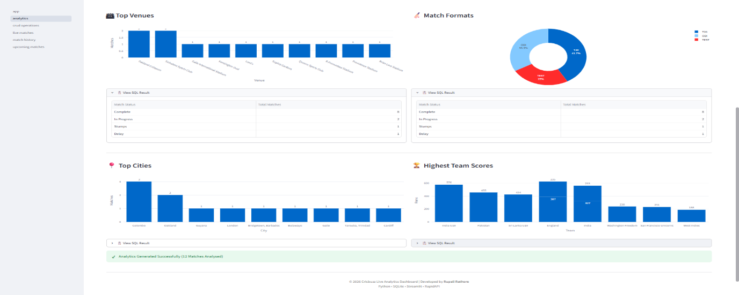
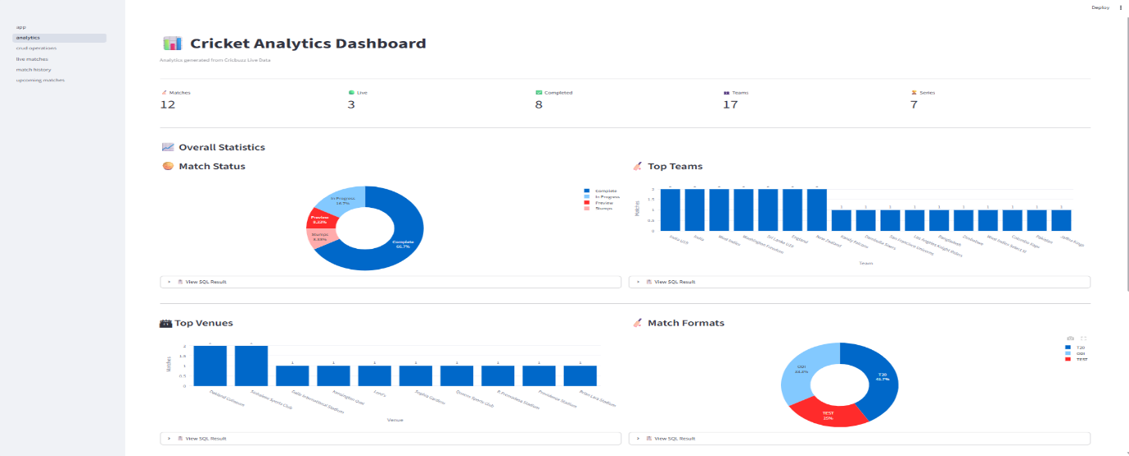
The Analytics module performs SQL-based analysis on the stored cricket data and presents the results using interactive charts and tables. It includes various analytical insights such as match status distribution, match format distribution, top teams, top venues, top cities, and highest team scores. This module helps users understand cricket data through meaningful visualizations.
Figure 8: Analytics Module
10. SQL Queries & Analytics
The Cricket Live Analytics Dashboard uses PostgreSQL to store and analyze cricket match data collected from the Cricbuzz API. SQL plays a vital role in retrieving, filtering, summarizing, and analyzing match information. The application executes more than 25 SQL queries to generate dashboard statistics, perform CRUD operations, and produce analytical insights.
These SQL queries are used to calculate match statistics, identify top-performing teams, analyze venues, filter records, maintain historical data, and support real-time dashboard updates.
Major SQL Queries Implemented
Query 1 – Total Matches
Purpose: Counts the total number of matches stored in the database.
SELECT COUNT(*)
FROM matches;
Query 2 – Total Live Matches
Purpose: Retrieves the number of currently live matches.
SELECT COUNT(*)
FROM matches
WHERE state IN (
'In Progress',
'Stumps',
'Lunch',
'Tea',
'Drinks',
'Innings Break'
);
Query 3 – Completed Matches
Purpose: Counts the number of completed cricket matches.
SELECT COUNT(*)
FROM matches
WHERE state='Complete';
Query 4 – Total Teams
Purpose: Calculates the total number of unique teams.
SELECT COUNT(*)
FROM (
SELECT team1 AS team FROM matches
UNION
SELECT team2 AS team FROM matches
) AS teams;
Query 5 – Total Series
Purpose: Counts the number of unique cricket series.
SELECT COUNT(DISTINCT series_name)
FROM matches;
Query 6 – Match Status Distribution
Purpose: Groups matches according to their current status.
SELECT
state,
COUNT(*) AS total_matches
FROM matches
GROUP BY state
ORDER BY total_matches DESC;
Query 7 – Match Format Distribution
Purpose: Displays the distribution of matches across different formats.
SELECT
match_format,
COUNT(*) AS total_matches
FROM matches
GROUP BY match_format
ORDER BY total_matches DESC;
Query 8 – Top Teams
Purpose: Identifies the teams that have played the highest number of matches.
SELECT
team,
COUNT(*) AS total_matches
FROM
(
SELECT team1 AS team FROM matches
UNION ALL
SELECT team2 AS team FROM matches
) AS teams
GROUP BY team
ORDER BY total_matches DESC;
Query 9 – Top Venues
Purpose: Retrieves the venues that hosted the maximum number of matches.
SELECT
ground,
COUNT(*) AS total_matches
FROM matches
WHERE ground IS NOT NULL
GROUP BY ground
ORDER BY total_matches DESC;
Query 10 – Highest Team Scores
Purpose: Displays the highest team scores recorded in the database.
SELECT
team,
runs
FROM
(
SELECT team1 AS team,
team1_runs AS runs
FROM matches
WHERE team1_runs IS NOT NULL
UNION ALL
SELECT team2 AS team,
team2_runs AS runs
FROM matches
WHERE team2_runs IS NOT NULL
) AS scores
ORDER BY runs DESC
LIMIT 10;
SQL-Based Analytics Performed
The implemented SQL queries generate the following analytical insights:
- Total Matches
- Live Matches
- Completed Matches
- Total Teams
- Total Series
- Match Status Distribution
- Match Format Distribution
- Highest Team Scores
- Top Teams
- Top Venues
- Top Cities
- Historical Match Records
- Team-wise Search
- Venue-wise Filtering
- City-wise Filtering
- Match Format Filtering
- Match Status Filtering
- CSV Report Generation
- Dashboard KPI Generation
Conclusion
More than 25 SQL queries were implemented in this project to perform real-time data analysis, dashboard generation, filtering, and historical record management. These queries provide meaningful cricket insights and support the interactive features of the dashboard.
11. Results and Discussion
The Cricket Live Analytics Dashboard was successfully developed and tested using real-time cricket data fetched from the Cricbuzz API. The application successfully integrates API data collection, PostgreSQL database management, SQL analytics, and interactive Streamlit visualizations.
The major outcomes achieved during the implementation are summarized below.
Project Outcomes
- Successfully integrated the Cricbuzz RapidAPI for retrieving live and upcoming cricket match data.
- Stored live and historical match records in a PostgreSQL database.
- Implemented centralized dashboard-based synchronization for live and upcoming cricket data, supported by the scheduler module for periodic updates.
- Developed six interactive dashboard modules using Streamlit.
- Executed more than 25 SQL queries for statistical analysis and dashboard generation.
- Implemented search and filtering functionality using SQL.
- Generated interactive visualizations using Plotly Express.
- Enabled CSV export functionality for historical records and match data.
- Designed a modular and scalable project architecture.
Discussion
The developed dashboard successfully demonstrates the complete data analytics workflow, starting from data acquisition through API integration to visualization using an interactive web interface. PostgreSQL provides efficient storage and retrieval of cricket data, while SQL queries generate meaningful analytical insights.
The modular architecture improves maintainability and allows future enhancements such as player analytics, win prediction models, automatic scheduler activation, and cloud deployment.
The centralized synchronization mechanism improves data consistency across all dashboard modules and ensures that users always interact with the latest available cricket information.

12. Conclusion
The Cricket Live Analytics Dashboard successfully demonstrates the implementation of a real-time sports analytics application using Python, Streamlit, PostgreSQL, SQL, and Cricbuzz RapidAPI. The project integrates API-based data collection, database management, SQL analytics, and interactive visualization into a single platform.
The centralized dashboard synchronization mechanism ensures that live and upcoming cricket information remains consistent across all modules while maintaining historical match records without duplicate entries. The modular architecture makes the application scalable and suitable for future enhancements such as machine learning-based match prediction, player analytics, and cloud deployment.
Overall, the project provides practical exposure to real-world data analytics, REST API integration, relational database design, SQL querying, and dashboard development.
13. References
1. Cricbuzz RapidAPI Documentation
https://rapidapi.com/
2. Streamlit Documentation
https://docs.streamlit.io/
3. PostgreSQL Documentation
https://www.postgresql.org/docs/
4. Plotly Express Documentation
https://plotly.com/python/
5. Pandas Documentation
https://pandas.pydata.org/
6. Python Official Documentation
https://docs.python.org/

.

